

2022
Name:
The Options Process
During January and February, you will need to make important choices about the subjects you will study in years 10 and 11 so you can hand in your final options form in March.
This booklet helps with the thinking you will need to do if you are going to make sensible, informed choices.
You will work through this booklet at home during registration time starting on Monday 7th February. Each day you will have different activities to complete that will help you to reflect on your areas of strength and interests. On Wednesday 9th February, you will have options hour, which will include another assembly that will tell you information about the curriculum at Key Stage 4, the subjects you have to study, and the options available to you.
Your choices form will need to be returned no later than Friday 11th March. An electronic form will be shared with you to complete closer to the time once you have had your options interview with a member of the Senior Team. Make sure you use the time between now and then to think very carefully about what might be the best courses for you.
This booklet will start you on this process.

After the deadline date of
Friday 11th March,
you will not be able to change your mind.

It is important for you to realise that it may not be possible for you to do all of the subjects that you choose.

ACTIVITY 1: Monday 7th February

What does and what does not matter most when I make my choices?

Look at the list below and read through the reasons for choosing a subject.

Rank order them. Put 1 by the reason which you think is the most important for you to consider when choosing a subject. Put 2 by the next most important, and so on, down to 8 by the least important reason.

Don’t forget to give a reason why each one is important or not.

•
Reason | Rank Order | Why is it important/not important?
I like the subject
I need it for my career
I’m likely to get a good grade
My friend is doing it
It suits my learning style
I like the teacher

I think it looks interesting

My teacher thinks I should do it

When you are making your mind up, do not be influenced by the things that do not matter and do not ignore the things that do matter.

ACTIVITY 2: Tuesday 8th February
Preparation for Options Hour
Tomorrow you will have a chance to speak to students and staff about the courses available to you to choose for your GCSE’s.
It will be really important for you to go and talk to as many different people in your 15 minute slot as possible. You may have some ideas of subjects you would like to talk to more than others, but it will be important for you to go to as many as possible so you get a good idea of everything available to you.
Use your time today to think about some questions you might like to ask staff and students about the courses.
QQ
Questions to ask students:

Questions to ask staff:

Subjects or Courses that you are particularly interested in:

ACTIVITY 3: Wednesday 9th February
Where am I now?
Before you decide what you want to do, it is useful to find out where you are now. Start with a review of your schoolwork by filling in the tables below from your latest Progress Check report.
Start to get a clear picture in your mind of which subjects you are best at.
What grades does my Progress Check say I will get in these subjects?

 | Predicted Grade | On course to meet target? | Effort | Would this be a suitable subject for me to study in Year 10 and 11?
Art
DT
Drama
English |  |  |  | Everyone studies this subject
Geography
History
ICT
Languages
Maths |  |  |  | Everyone studies this subject
Music
PE
RE |  |  |  | Everyone studies this subject
Science |  |  |  | Everyone studies this subject

What realistic targets can you set yourself?
 | GCSE Grade
 | 1 | 2 | 3 | 4 | 5 | 6 | 7 | 8 | 9
English Language
English Literature
Maths
RE
Science
French/German
History
Geography
Computer Science
ACTIVITY 4: Wednesday 9th February
If you work through all the tasks in this booklet and do lots of thinking and talking to different people, you should be ready to make sensible, well-considered option choices.

Which subjects will suit me most?
This task asks you to reflect on yourself a little bit more and the strengths that you have as a learner. Some students might enjoy practical activities more, so subjects like PE or Drama might be better for them. Others might enjoy more creative activities, so subjects like Art or Design Technology might be a sensible choice.
Look at the questions below:
Questions to consider | What about me?
Do you like practical subjects?
Are you creative?
Are you good at revising for written exams or prefer more coursework based subjects?
Are you academic? Do you think learning a foreign language would be useful to you?
Do you enjoy science? Are you in sets 1 or 2 and would like to do science more than once each day?
Which subjects do you like most?

ACTIVITY 5: Interview Preparation

Justification Sheet

In the five boxes below, you are going to explain why you have chosen your options in the order that you have. It is important that you give as much information as is possible as, during your interview with a member of the senior leadership team, you will be expected to discuss these reasons in detail.
EBacc Subject Choice: | Why?
Free Option 1: | Why?
Free Option 2: | Why?
Free Option 3: | Why?
Free Option 4: | Why?
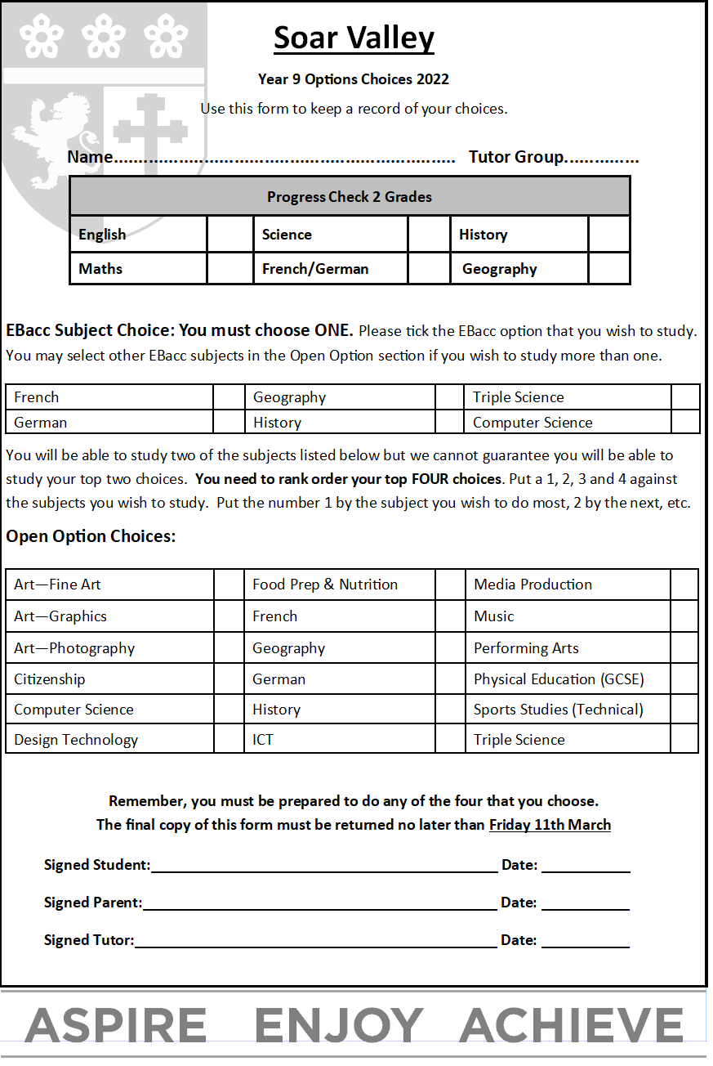

Checklist:
Tick off each of these tasks once they are completed.
Task | Completed?
Listened to Assembly 1 on Options
Completed the Which Way Now Booklet
Studied the Curriculum Booklet
Listened to Assembly 2 via Loom on Options
Attended Options Hour
Done my research and prepared for interview
Asked my parents for advice
Completed and returned electronic options form

