Soar Valley College
Transition Booklet
2024/5
My name is:

__________________________

My tutor’s name is:

__________________________

My tutor group is called:

__________________________

My peer buddies are called:

__________________________




A MESSAGE FROM THE PRINCIPAL

Dear Prospective Year 7 Student,

Welcome!

I am delighted you will be joining us next academic year. Soar Valley is a fantastic school! Yes, it is a great building and has wonderful facilities, but the thing that makes us so successful is the people. Everyone at Soar Valley is very proud of our excellent school, and soon you will be one of those people, and a very important part of our ‘family’.

Our school motto of ‘Aspire, Enjoy, Achieve’ really does mean something. We expect you, as a Soar Valley student, to aspire to do your best, to be involved and so enjoy your time here, and then to achieve highly, to do the best that you possibly can. You will quickly find out that, here at Soar Valley, we value effort above all else. We have high standards in all the things we do, and you will be expected to try your very best to meet those standards all the time.

You may be excited at the thought of starting a new school, but you may also have a few concerns. Please do not worry. Everyone here will give you all the help you need and you will soon settle in.

I look forward to meeting you all again soon.

Kind regards,

Mrs Robinson

Getting to know you
One of the main things you will do today is find out lots of information about new people. Below you will find some information about, Mr. Pankhania your Head of Year, and Mrs Williams, your Associate Head of Year, and finally you will have a chance to listen to your form tutor tell you a little about themselves.
Throughout the day you will also have the opportunity to tell people about you, and the sort of things you like and enjoy.

Head of Year 7: Mr. Pankhania
My name is Mr. Pankhania and I have been teaching for 7 years. I am a Science teacher and this is the 3rd year group I am taking on
I am most looking forward to:
Building relationships - Developing strong and supportive relationships with students, getting to know their strengths, interests and areas of growth.
Supporting school culture – Instilling positive values, behaviours and fostering a sense of community and belonging within a year group
Celebrating milestones – Being part of a students’ important milestones and achievements throughout the year.
I love football and am a big Manchester United fan. I also love F1 and a Ferrari fan
I enjoy spending time with my family and my two children Rian and Aria

My tutor’s five objects
1 | 2 | 3 | 4 | 5
 |  |  | 

Associate Head of Year 7: Mrs Williams

My name is Mrs Williams and I’m going to be the AHoY for Year 7
This will be my 20th Year at Soar Valley College, it was also my secondary school when I was younger.
I’m looking forward to getting to know the Year 7s & supporting them to aspire, enjoy & achieve
My hopes for this cohort are excellent attendance, effort & behaviour. I do not tolerate any form of bullying
In my free time I enjoy going on holiday, eating out, visiting the cinema, reading & binge watching series

Starting at a new school means you’ll meet many new people, both students, teachers and staff. Some of the most important new people you’ll meet on the induction day and at the start of term are your form tutor and of course your new form members. These are people you’ll spend the next few years with. Remember, a stranger is just a friend you haven’t met yet.
Use the space below to introduce yourself. Talk, draw or mind map about what you love to do in your free time, what hobbies you have, what interests you but most importantly, what makes you the person you are. Choose one of the following:
• Draw a picture to introduce yourself, maybe of one of your interests
• Write a passage of text all about you, your hobbies or other interests.
• Create a mind-map of all of the stuff that makes you who you are.

Our motto of ‘Aspire, Enjoy Achieve’ encapsulates the ethos of our school where you are encouraged and supported to do the best you can do, and to be the best you can be.
We strongly believe that in order to do this all students must develop and demonstrate three key qualities derived from our Core Values.

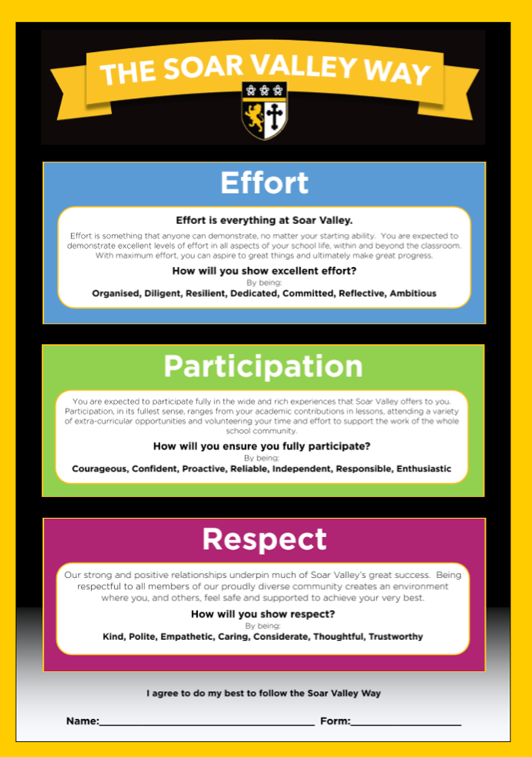

The Soar Valley Way, underpins all of the great work we do here at Soar Valley. Over the next few pages you are going to do a series of tasks that get you to start thinking about The Soar Valley Way and what life will be like when you start with us in August.

Activity 1: What are you worried about in moving up to secondary school?

Tick the ones that are most appropriate.

Worried you can’t do things | Scared of taking risks
Scared of the new work and that it will be too hard | Being away from friends
You’ll find it hard to focus | Getting lots
Feeling stressed or anxious | Getting things wrong or feeling foolish


Activity 2: What is different at secondary school?

What is different at a secondary school?

Activity 3: How to overcome the challenges
The Challenge:
How to overcome the challenge:

The Challenge:
How to overcome the challenge:

The Challenge:
How to overcome the challenge:

The Challenge:
How to overcome the challenge:

The Challenge:
How to overcome the challenge:

Use the table below to list the 5 biggest challenges chosen by your tutor group. Make a list of ways in which you could overcome them.

Activity 4: Find someone who…

At Soar Valley you will meet lots of new people. You will need to speak and work with others on a regular basis.

This task requires you to speak to other students in your tutor group and find something out about them you didn’t already know.

Your task is to find at least 1 student who can say yes to the following statements. When you have found them write their name next to it. Try to get as many different names as you can.

Likes Chinese food
Watches Eastenders
Plays in a cricket team
Plays the piano
Has a poster on their bedroom wall
Owns a Dua Lipa album
Has a pet dog
Their favourite colour is yellow
Has read all the Harry Potter books
Supports Leicester City
Hates Nutella
Has an older sibling
Has size 5 feet
Owns a BMX bike
Straightens their hair
Has travelled abroad
Dislikes the Ed Shearan
Catches the bus to school

Activity 5: My Day at Soar Valley

How did I feel this morning?
What descriptive words could you use in your sentences? What emotions do you know?
How have you demonstrated Effort, Participation and Respect today?

I have demonstrated good effort today by…..

One way I have participated today is……..

I have been respectful today by…….

What are you looking forward to about starting at Soar Valley College in August?

Key Information

You should find time over the summer holidays to sit and read through the following pages. This would be best done with your Parents / Carers as this information is also useful for them.

Reading is very important to us at Soar Valley. Why not practice and read the following pages aloud to your parents / carers







Soar Valley – A Day in the Life

Event | Timings
Learning Resource centre opens | 08:00
Registration | 08:45-09:00
P1 | 09:00-10:00
Break | 10:00-10:20
P2 | 10:20-11:20
P3 | 11:20-12:20
Lunch | 12:20-13:00
P4 | 13:00-14:00
P5 | 14:00-15:00

What should I do now?

Read the instruction and write in the correct time.
Time for lunch! |  | Breaktime
Good morning!  Please go to your form room! |  | Time for first lesson
Time to go home |  | Time for last lesson

HELP!
Where do I go & who do I ask?
Normally the best person to ask for help is your Form Tutor. They are the best person to help you solve your problem. If they are not available you should ask Mrs Williams or Mr Pankhania However, all staff will be willing to help you and sometimes it will be best to go directly to them.

Look at the table below. For each of the reasons you may need help, draw a line to the most appropriate person/place you should go to (there may be more than one correct answer). Good Luck

Reasons you may need help |  | What shall I do?
I need to buy a new lanyard |  | Go to Welfare
I fell over at break and hurt myself |  | Look in the Lost Property box opposite the Medical Room
I can’t find my school blazer |  | Go to the Library
Another student is teasing me at break time |  | Ask anyone on the corridor
I don’t feel well |  | Go to Student Reception
Another student is teasing me during a lesson |  | Look at the plan of the school in this booklet
I want somewhere quiet to work after school |  | Speak to your teacher at the start of the lesson
I have forgotten to bring my homework to school |  | Speak to your teacher
I’m not sure where to find my next lesson |  | Check if it is in any of the classrooms you have been in
I need to get into my locker but I have lost the key |  | Go to reception and ask for it to be opened but only during registration

Anti-Bullying

What do we mean by bullying?
“Behaviour by an individual or group usually repeated over time, that intentionally hurts another individual or group either physically or emotionally”.

The “Several Times On Purpose” – S T O P - and “Start Telling Other People” –S T O P - theme has been adopted by Soar Valley College.
We take bullying at Soar Valley very seriously. As a result of this we have been awarded the Anti-Bullying Community Award from Leicester City Council for all the work we do to prevent bullying at Soar Valley.

Bullying can be - Physical, Verbal, Emotional, SEN/Disability, Cyber bullying, Racial, Sexual, Homophobic, Religious, Home Circumstances, bullying due to appearance or health conditions.
None of these are acceptable behaviour at Soar Valley.

S.T.O.P
Several Times On Purpose
What should you do if you are being bullied or see someone being bullied?
- Walk away from the bullies if you can
- Tell them you will report it – don’t just be a bystander
S T O P!
Start Telling Other People

- Tell a teacher as soon as you can – do NOT keep it to yourself because we can’t do anything about bullying incidents unless you tell us! OR you can
- Post an Anti-Bullying Referral form in the STOP box outside the Welfare Office OR you can
- ALL reports of bullying are taken seriously and followed up by staff
- You WILL be listened to
- You WILL be supported
- If you are involved in any form of bullying of others you will be punished
- We DO NOT tolerate any form of bullying at Soar Valley
REMEMBER – no matter what the situation is there is always someone you can turn to.

