**Literacy Tasks**

The next few pages are concerned with developing your subject specific literacy. Match up the key words on the left with the descriptions on the right.

For any words you are not sure on, try being a detective and look in the dictionary and do some research!

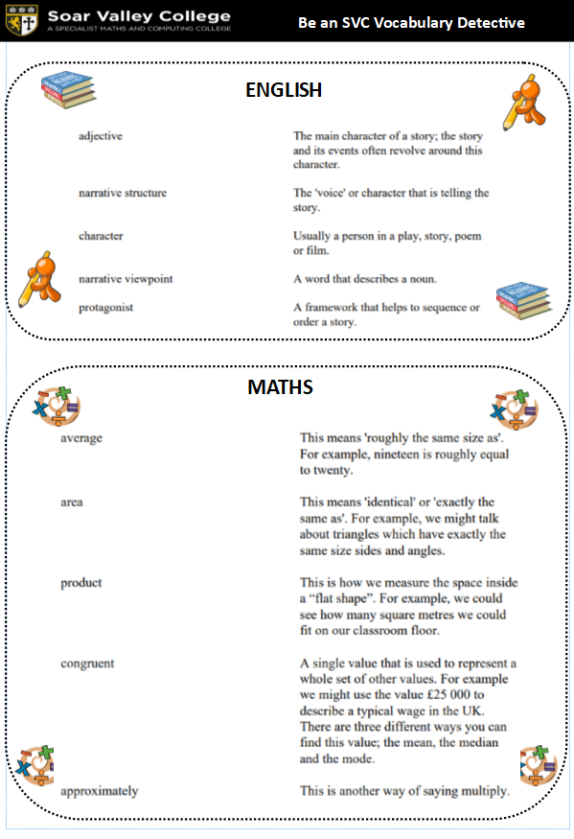

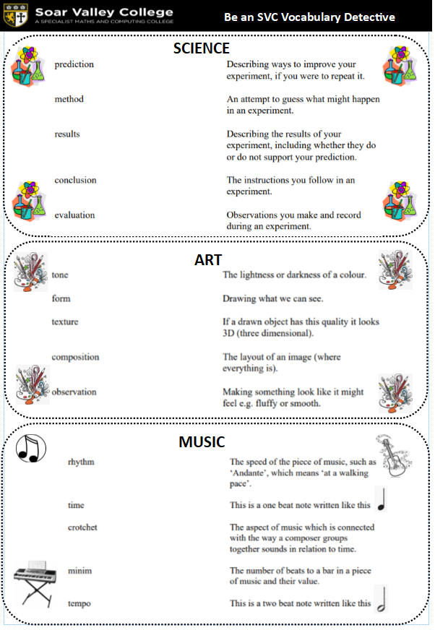

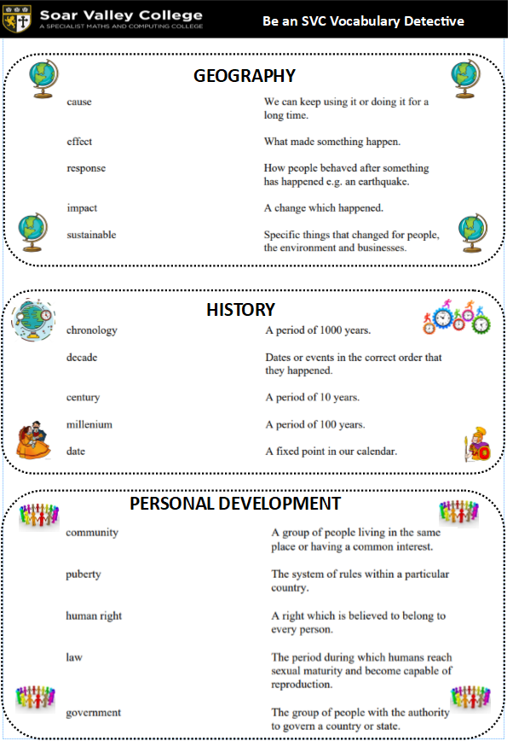

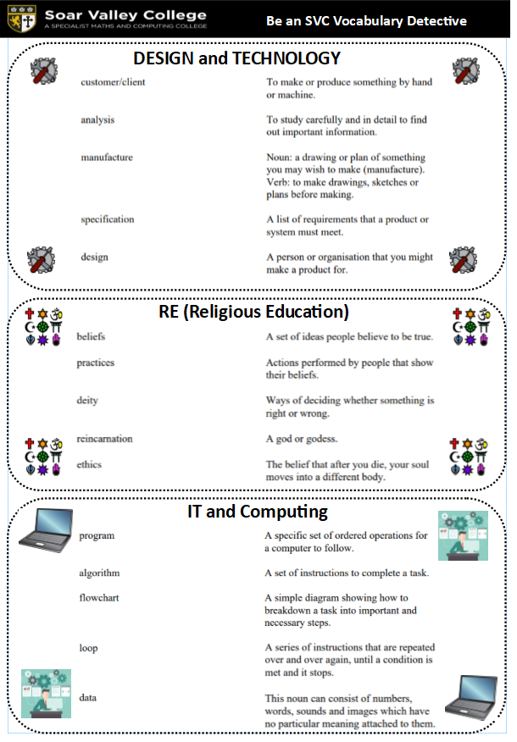

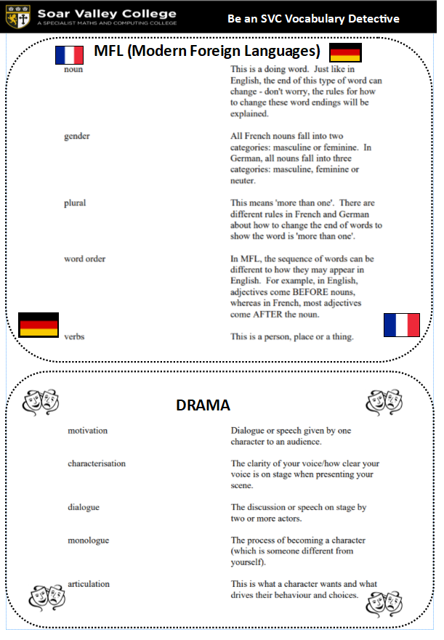

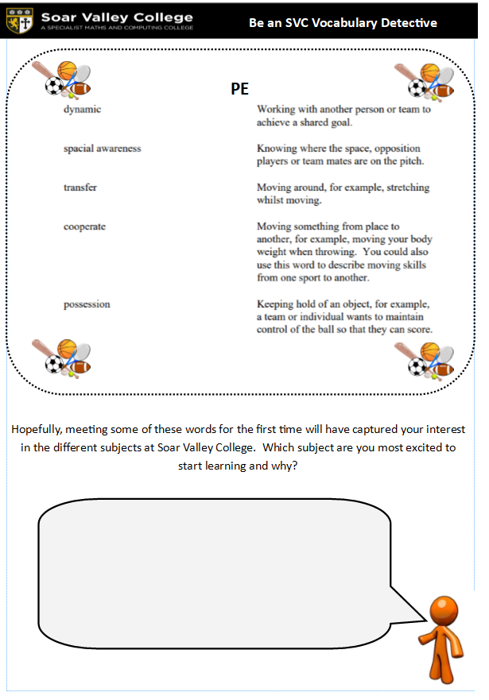

**Subject Activities**

This part of the summer home learning booklet is about preparing you for learning at Soar Valley in Year 7. Each subject area has created some activities for you to carry out that will set you up well and give you an idea about the sort for work you will be doing in September.

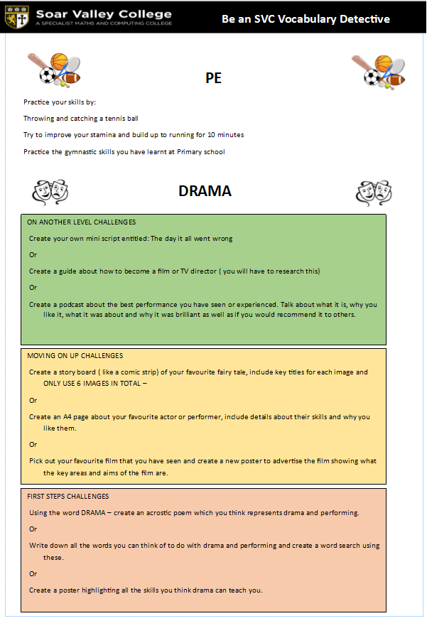

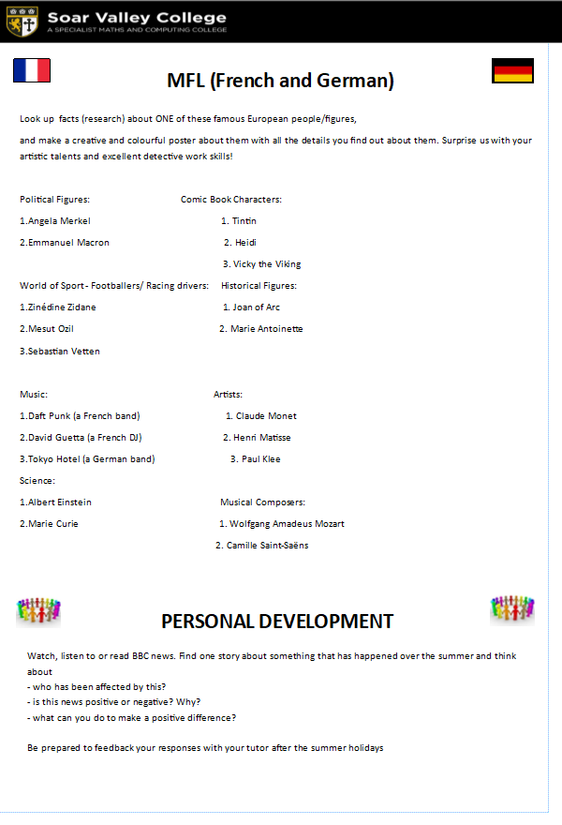

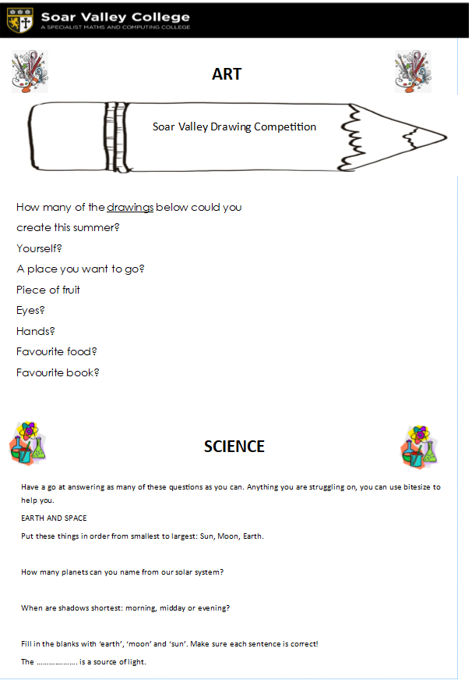

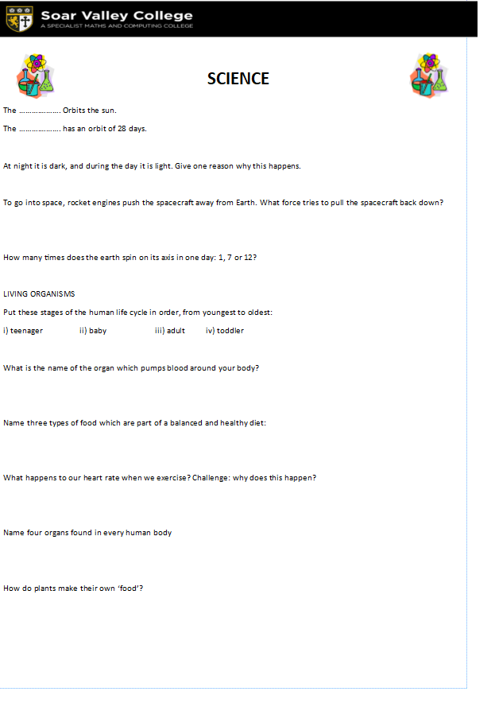

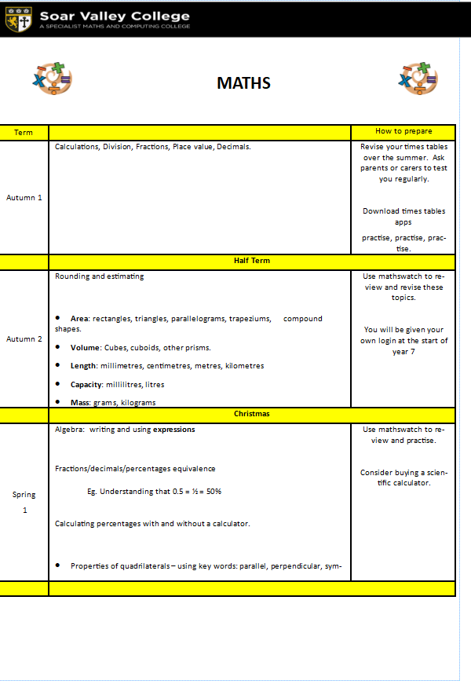

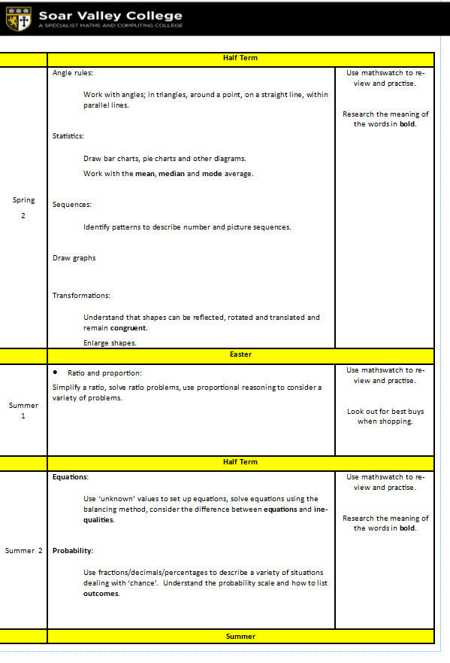

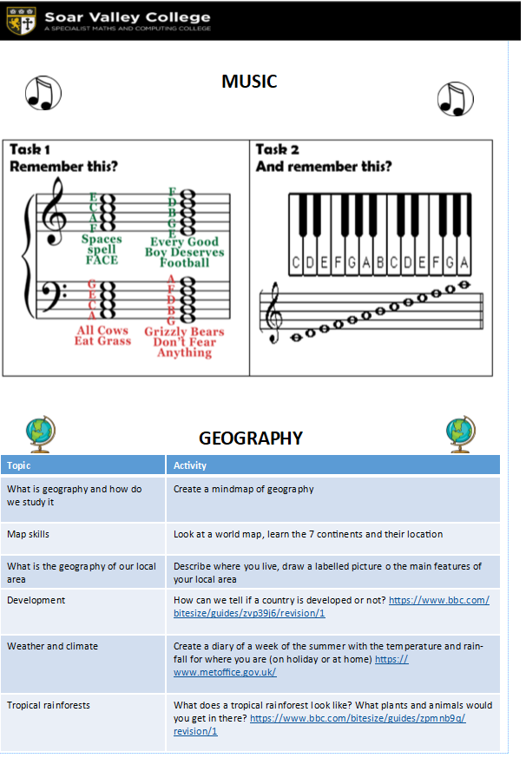

**Religious Education – interview task**

***If you follow a religion***, interview a religious leader  (e.g. imam, vicar, priest, rabbi) with the following questions and note down what they say:

1. What do you think are the three most important **beliefs** of our religion?
2. What do you think are the three most important **practices** of our religion?
3. In your view, what makes being a **Buddhist / Christian / Hindu / Jew / Muslim / Sikh** special?

***If you don’t follow a religion***, interview a friend or family member who has a strong belief about something in their lives. This could be, for example, a religious belief that they follow but you don’t, or a belief in a football team, or a belief about how to treat animals…

Ask them the following:

1. **Why** do you believe what you believe?
2. **What difference does it make** to your everyday life? (i.e. what do you do differently because of the belief?)

**DESIGN TECHNOLOGY**

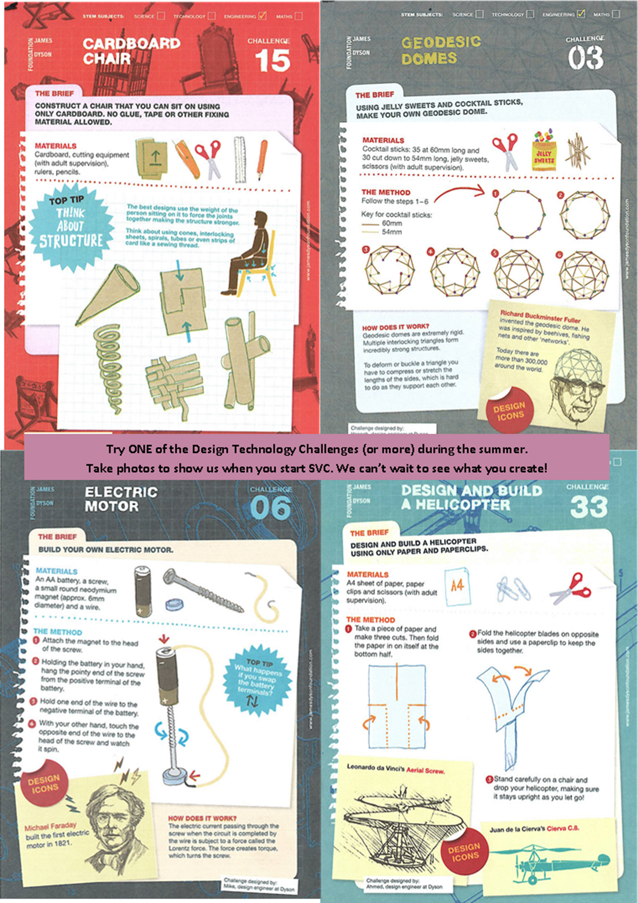

**Soar Valley College**

**Summer Home Learning Booklet**

**2024/5**

**My name is:**

**__________________________**

**My tutor’s name is:**

**__________________________**

**My tutor group is called:**

**__________________________**

