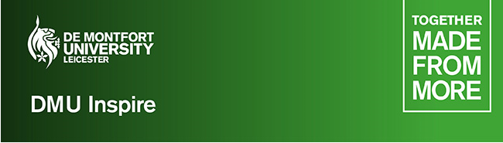

Hello!

DMU have launched the DMU Inspire Easter programme 2024.
This is a free (lunch is provided), exciting, immersive, one, two or three day experience, at the De Montfort University (DMU) campus. The experience is open all year 10 and year 11 students.
This experience will be run during the Easter holiday where students will join DMU academics and experts in their specialist areas, to develop skills that will help with future education progression and with college/sixth form and university personal statements.
There are 11 schools/streams available below. Students can apply for one stream.
Each day will run between, 9am till 3 or 4pm.

Paramedic Science School – Monday 25 March

Learn what it takes to be a paramedic – get hands-on practical experience using our state-of-the-art simulation equipment, learn what it takes to provide first aid to non-responders and more.

Creative Fashion and Textiles – Monday 25 March
Join our creative Fashion and Textiles team in hands-on, creative workshops

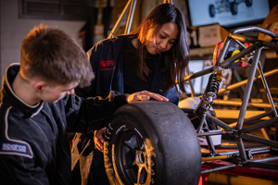
Engineering and Technology School – Monday 25 March
Explore innovative developments and take part in exciting workshops and demos in our Engineering and Technology experience.


Creative Writing School – Tuesday 26 March
Learn to think (and play) creatively through interrelated sessions led by writers from DMU's Creative Writing degree programme.

Devising Drama School – Monday 25 & Tuesday 26 March
Work with expert staff from the Drama and Performance team at DMU to explore new techniques that will give learners a toolkit for devising your own work.


CSI Leicester school – Tuesday 26 March
This practical and hands-on experience will take you through the crime scene to court process.

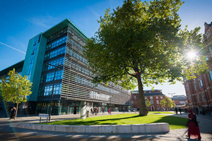
Young Entrepreneurs - Business School – Tuesday 26 March
This session is designed to give students the basic tools and ideas for thinking about and shaping new business ideas.


Magic, Manipulation, and messing with your mind (English Language) School – Wednesday 27 March
Ever wondered why we talk about 'spelling'? Over the course of this stream, you'll learn something about the history of magic and magical languages, deception, manipulation, and more...

Creative Design School - Wednesday 27 March
Join the Creative Design team for day of artistic exploration with real-world outcomes, immerse yourself in contemporary design and immerging technologies through a series of workshops.

28

Film and Media School – Thursday 28 March
Join members of the Film Studies team for a day of film-related activities intended to get you thinking about how and why the media works.


Law School – Date TBC
This one-day experience is a fantastic opportunity to learn about criminal law, how to win an argument and how our human rights are infringed, not only at home but on an international scale.

Students can apply via the online application form. It’s only short. But useful for students, when applying to note, the most important part of the form is the ‘Statement of Interest’ section. This is their opportunity to clearly demonstrate to us their passion and enthusiasm for the stream or subject area, and tell us more about any relevant experiences they've had.
DMU Inspire online application forms can also be found here:

As this is during the Easter holidays, you will need to ensure your son/daughter is dropped off at DMU campus for the start time, and picked up at the end time.

Place available for each school/stream are limited, to secure a space, we recommend students apply as early as possible.

Once your son or daughter applies and has successfully gained a place, more joining information will follow.

We’re really looking forward to welcoming your son/daughter onto campus.

If you have any questions, please don’t hesitate to contact schoolsoutreach@dmu.ac.uk

Best wishes,

The DMU Widening Participation Team

DE MONTFORT UNIVERSITY
dmu.ac.uk/wp


@dmu.wp

